4 Health Benefits Of Jumping Castles

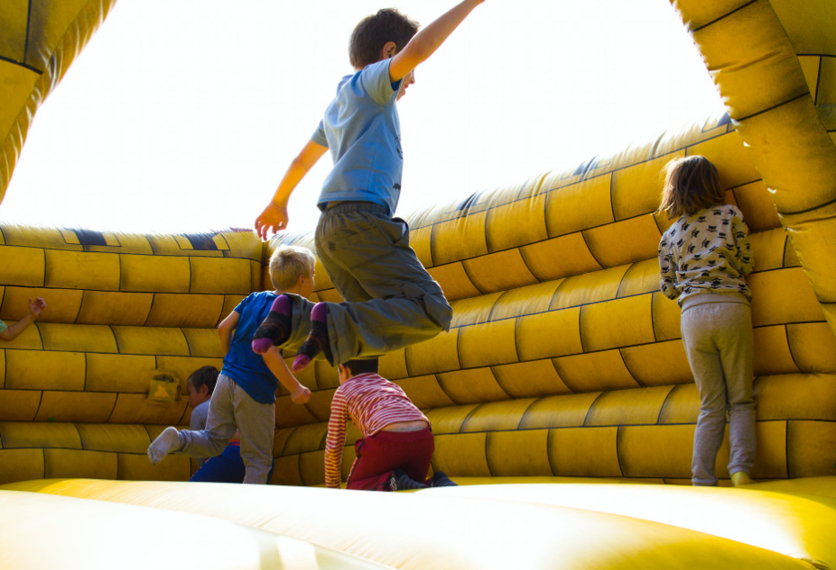

Most kids will do anything to play in a jumping castle. While these kids might simply be looking to experience the thrill, studies have shown jumping castles to be an excellent source of exercise for most children. Unknown to many, these castles offer surprising health benefits, a reason you too should consider hiring one for your kid’s next birthday party.

In need of a jumping castle for your child’s next birthday party? Contact the team at Super Castles today!

1. Improve Balance and Coordination

The wobbly surface of jumping castles makes the perfect environment and surface for kids to learn the art of staying balanced, especially with other kids jumping up and down.

Bob Lane, an Australian hypnotist by trade, notes that his kids love jumping castles because they continually fall over but keep getting back up. “No matter how many times my kids fall down on one of those jumping castles, they just get right back up and keep bouncing around like nothing happened. I don’t think I could fall over and keep getting up like that myself!”

While they might fall off a few times, it is only just a matter of time before they can get a footing and maintain balance unaided. Allowing your kids, even as young as 3, to play in a jumping castle will help improve their coordination and balance.

2. Improved Lymphatic Movement and Blood Circulation

As mentioned before, jumping castles are an excellent source of exercise for your kids. Simply jumping up and down forces the heart to pump a lot harder to send blood to all parts of the body. This form of exercise is also known to improve their lymphatic system and contribute to improved stamina and a healthy heart.

3. Promotes Better Mental Health and Social Interaction

The wake of electronic devices and video games has made it almost impossible for kids to interact with their peers. Jumping castles, however, help curb this, as every kid will want to have a taste of the thrill. This thus allows them to go outside and play with other children, improving their social interaction skills.

Australian health and wellness expert Sally Austin believes that allowing children to build social interactions from a young age is vital. “At those ages, your mind wanders free and you don’t have all of the views and perhaps prejudices that you have when you grow older. There’s something so natural about kids that age playing around, and doing that in a jumping castle is a great way for them to grow their social interaction skills.”

Allowing kids to play together makes them more sociable and is good for their mental health. It also enables them to develop problem-solving skills while on the castles too.

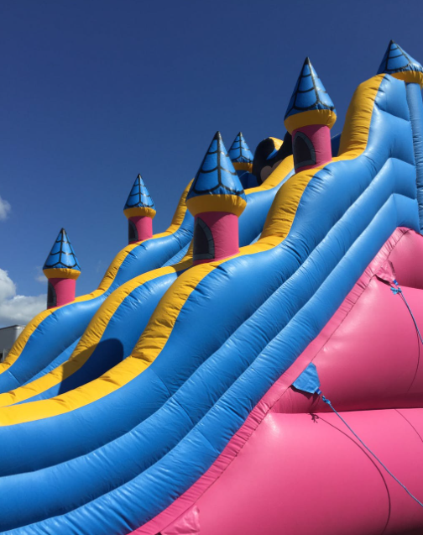

4. It Gives the Kids A Chance to Play Outside

The increased access to gadgets and toys encourages most kids to spend most of their time indoors. Very few ever yearn to go outside to play.

For Australian roofing entrepreneur Richard Gabriel, he remembers that nothing was more exciting than getting outside and playing when he was a kid. “It was the best - you had no worries, you were just making up your own games and having fun as you went along. Doing that with a jumping castle is honestly the cherry on top.”

Mounting a jumping castle in the yard, especially when holding a birthday party, will make all the kids attending want to spend time outdoors on the castles. This thus gives them a chance to enjoy the fresh air outside and even get some vitamin D from the sun.

If you’re not convinced about hiring a jumping castle for your child’s next party after getting this far in the article, we don’t know what else could convince you. But if you’re still with us and looking to organise a jumping castle, you’re in the right place at Super Castles.

With a ton of different designs to suit your child’s favourite TV show or movie, Super Castles is the only jumping castle company you should hire from. Get in touch with our team today to book your next jumping castle!

